www.omrsoftware.net

Congratulations on downloading the Cube OMR Sheet Reading Software Complete test correction solution!

Installation Instructions

YOU MUST FIRST HAVE A PRINTER AND SCANNER INSTALLED AND FUNCTIONAL ON THE COMPUTER THAT WILL BE USING THE PROGRAM! The program will use the existing TWAIN drivers that are automatically loaded when you correctly install your scanner on your PC.

You have downloaded the software in a zipped format from the www.omrsoftware.net web site. When you double click the icon for the program, the installation process will begin. You will get a Shortcut on Desktop.
For Windows Vista and Windows 7 user right click shortcut and click Run as Administrator.
Below is the image you get when you start software for first time.

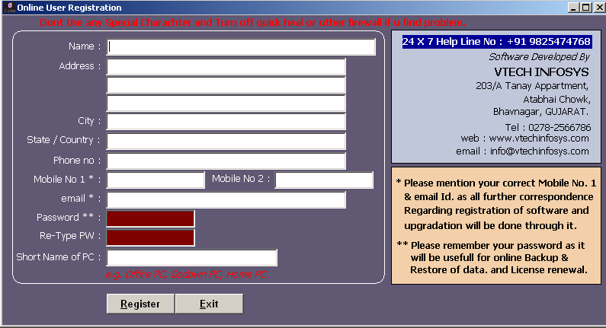

Fill in your detail so that we can contact you for future update of software and for other usefull information regarding software. You need to enter any password of your choice with which you can log in to our server and get license key in case you format your system.

Once your PC is registered with our server you will get 30 days validity. Every time you start software you will get welcome screen. You can press escape or simply close welcome screen.
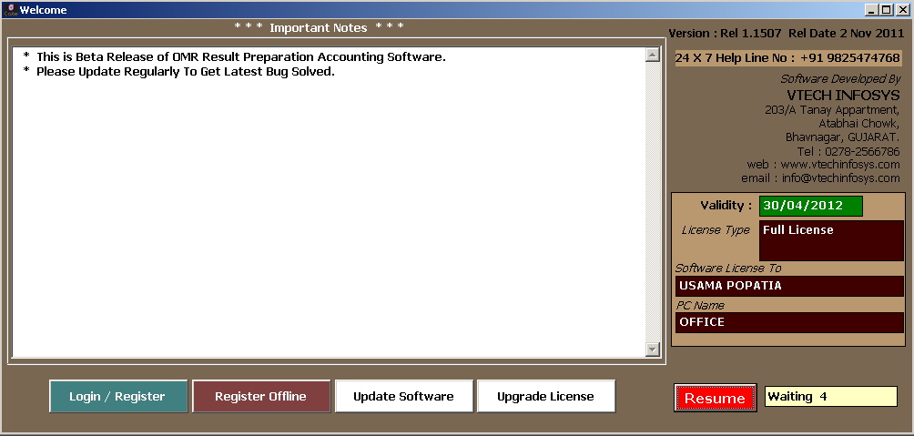
Next you will get company menu Just Double click on DEMO TUTION CLASS and Then click GO option
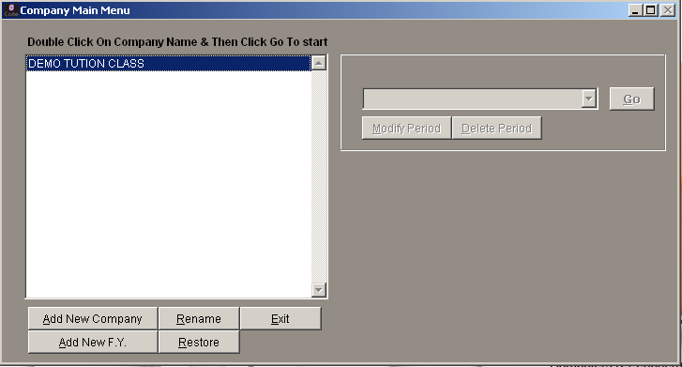

Click Transactions in MENU and go to Blank OMR Sheet Option
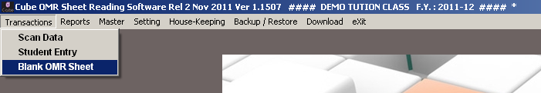

There are 6 Different kind of OMR Sheet available as per your requirement. Select proper OMR Sheet you need to check here we will select 3) 100 Marks (ABCD) sheet for testing. Select number of copies you need to print and print blank OMR Sheet.

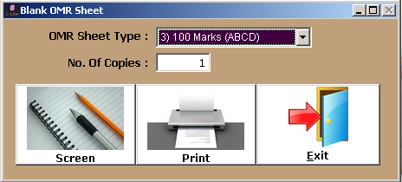

Just do proper marking in OMR Sheet which you have printed
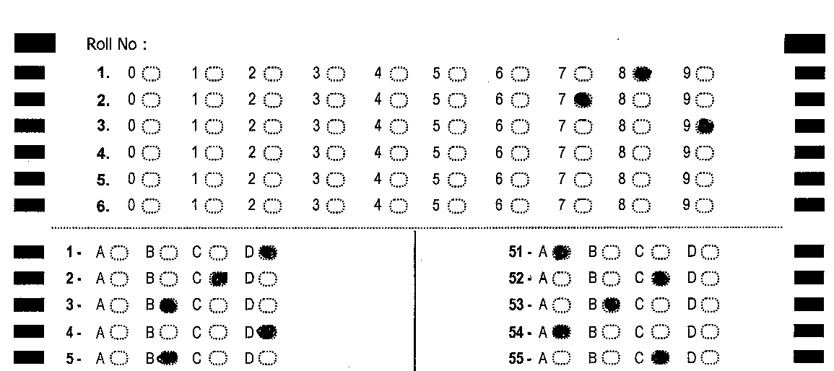

After marking sheet go in Transactions -> Scan data

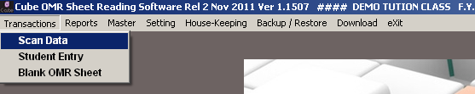

Normal Marks OMR Sheet Scanning
In scan data entry click ADD button. Select 3rd OMR Sheet select standard and subject. Write number of marks you want to scan. First you will have to give Master Answer sheet so that software can compare student sheet with write answer key. If you have Marked master answer sheet then click Red Scan button or else click Pink Manual Answer Sheet button to fill correct answer manually.
If more then one scanner is attached with computer click select scanner and choose proper scanner.
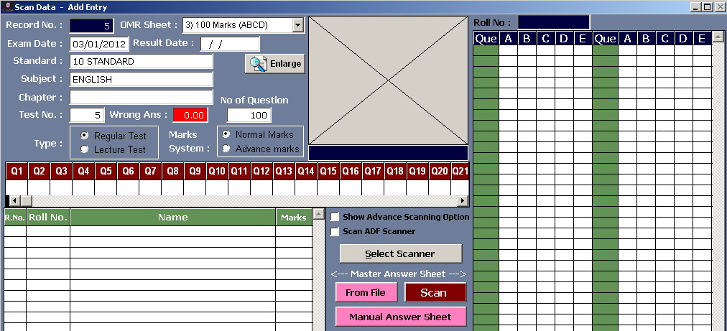

On Clicking Manual Answer Sheet button you will get bellow screen where in you can add right answer key

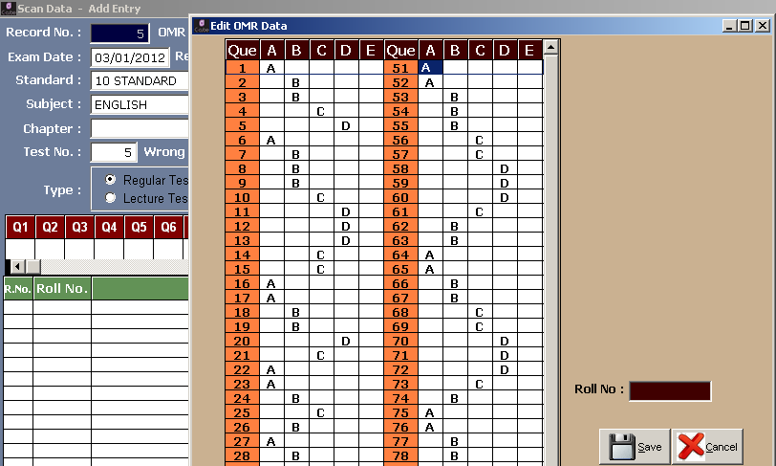

When you are done entering Master answer sheet Green Scan button will be enabled. Put student sheet in scanner and press Green Scan button. Software will scan student sheet and give scoring. Once you are done scanning all student sheet click save button.

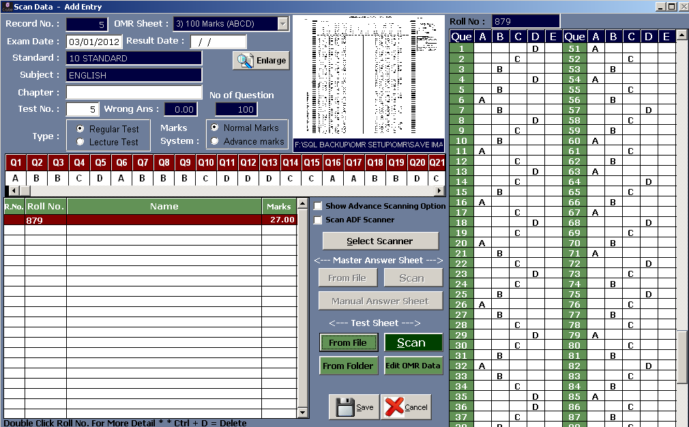

As shown in image bellow if more then one option is selected it will be displayed by letter “x” and none of answer is marked letter “@” will be displayed. If software is unable to scan data letter “?” will be displayed. There are few troubleshoot which you can do if you get “?” letter.

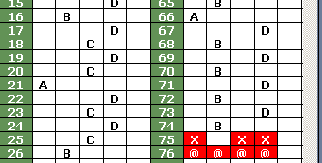

Troubleshoot of Invalid Image Scan Data
- Check page is scanned in right direction go to “D:\OMR\OUTPUT” folder open scan.tif file if you are scanning from ADF scanner open multi.tif file. Keep page in right direction title on top.(“D:\OMR” is the default path were software is installed if you have installed in some other location open that folder)
- If page is not straight you will get error its not necessary that page is scanner must be 100% straight little sliding will work but if its too much difference data will not be scanned properly.
- It is strictly recommended to print OMR sheet on A4 paper and it is also necessary to keep paper at A4 marking in scanner. There is marking for A4 paper in every scanner so keep paper as per that marking.
- Still if data is not retrieved from image email scan.tif or multi.tif file to info@omrsoftware.net

Advance Marks OMR Sheet Scanning

In advance marks you can give different scoring in single test for e.g. you have a 100 Question test with 3 different kind of scoring. Just click on Advance Marks and a new window as bellow will open.

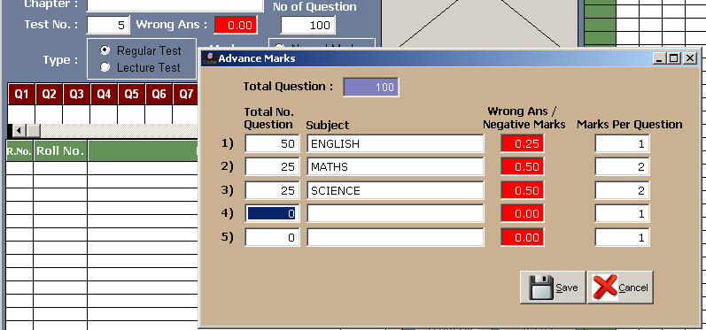

Here in above example there are 50 Question of subject English 1 marks each with .25 for each wrong answer,
25 Question of subject Maths 2 Marks each with .50 for each wrong answer, 25 Question of subject Science 2 marks for each question with .50 for each wrong answer. After giving criteria as per your need click save now when you scan student sheet you will get marks as per criteria you set earlier. Other all procedure remains same as above.

Report & Result

Reports -> Test Wise Result

Just by pressing enter you will get default value. Click desired output type Screen/Printer/Pdf/Excel
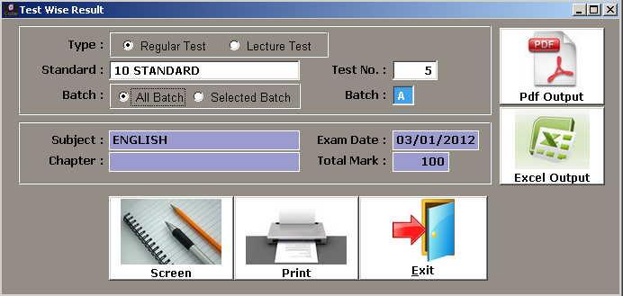
Click Excel Output and you will get output in Microsoft excel as bellow
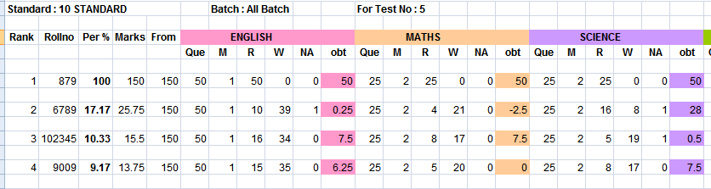

Here Que=No of Question
M =Marks
R=Right Answer
W=Wrong Answer
NA=Not Answered
Obt=Obtained Marks

Reports -> Test Wise Result (With Right Answer Key)

Bellow is the screen output of report. You can see correct answer key of test. If answer is wrong you will get one of the three sign to indicate the reason behind wrong answer *=Wrong Answer @=No Answer Selected X=More then one answer selected
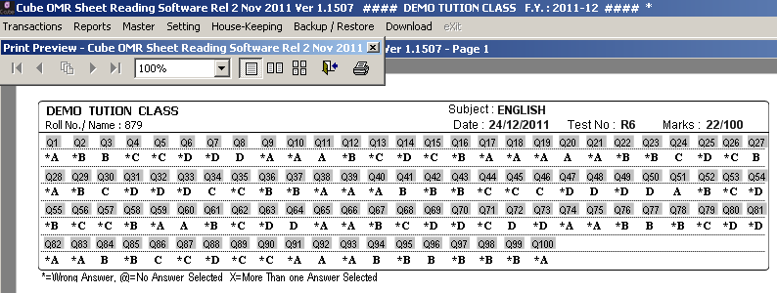
There are many more report available and there Is sms facility included by which you can send right answer key to student. We can also develop any kind of OMR sheet as per client demand. For any kind of queries email us.

Email Address: info@omrsoftware.net

Vtech Infosys
203 Tanay, Atabhai Chowk,
Opp Joggers Park,
Bhavnagar
GUJARAT. INDIA.
Cell : +91 9825474768 Office : +91 278 2566786
email : info@omrsoftware.net, vtech451@yahoo.co.in
web : www.omrsoftware.net

